Bandit level 5 to level 6
l login to the next level with the username as
And then use cd inhere command to transfer the file.
And then use the command find . -type f -size 1033c which means to find a file that exactly contains 1033bytes.
And then use cat command to display its content.
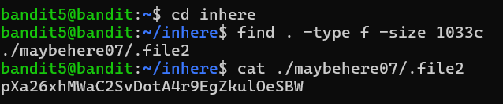
And then finally you will get the password for the next level which is the level 6

